HR Analytics Dashboard: Employee Attrition Analysis

This project presents a comprehensive HR Analytics Dashboard developed to monitor, analyze, and visualize employee attrition data. By leveraging advanced data visualization techniques, the dashboard provides a high-level overview of workforce stability, enabling stakeholders to identify critical retention risks. The solution processes complex HR data to deliver actionable insights regarding total employee count, attrition rates, and demographic distributions, facilitating a proactive approach to workforce management.
The analytical approach focuses on uncovering correlations between employee attrition and various organizational and demographic factors. Through rigorous exploratory data analysis (EDA), the project identifies key drivers of turnover, such as job satisfaction, distance from home, and departmental allocation. This analysis serves a vital business function by transforming raw HR data into strategic intelligence. By highlighting specific areas of concern—such as high attrition in the Sales department or among specific age groups—the dashboard empowers management to implement targeted retention strategies, optimize compensation structures, and improve overall organizational health.

Project Objectives

- Analyze employee attrition trends to isolate key factors influencing workforce turnover.
- Support Human Resources and executive management teams in making data-driven decisions regarding talent retention.
- Identify high-risk segments within the organization and propose potential areas for policy intervention.
- Visualize complex data relationships to facilitate intuitive understanding of workforce dynamics.

Key Performance Indicators (KPIs)
36.92
6.50K
7.01
1,480
Total Employees
16.1%
Attrition Rate
238
Total Attrition

Avg Years at Comp
Average Salary
Average Age

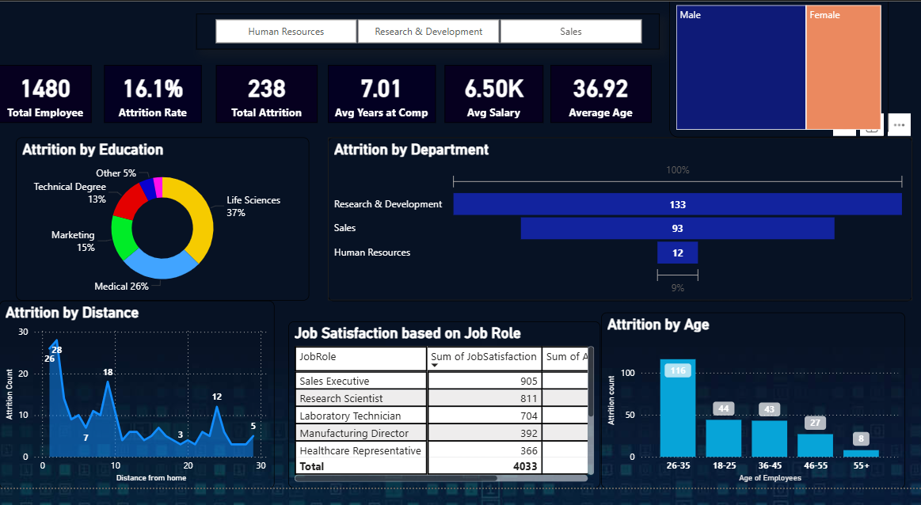

Analytical Dimensions

- Departmental Analysis: Breakdown of attrition across Human Resources, Research & Development, and Sales to pinpoint sector-specific issues.
- Education Background: Correlation analysis between employee education levels (e.g., Technical Degree, Medical, Life Sciences) and retention rates.
- Demographics: Distribution of attrition across age groups (18-25, 26-35, 36-45, 46-55, 55+) and gender.
- Work-Life Factors: impact of commute distance ("Distance from Home") on employee turnover.
- Job Satisfaction: Evaluation of satisfaction scores across different roles (e.g., Sales Executive, Research Scientist) to assess engagement.

Methodology

- Data Preprocessing: Performed extensive cleaning to handle missing values, inconsistencies, and data type formatting, ensuring high data quality.
- Exploratory Data Analysis (EDA): Conducted statistical analysis to detect patterns, outliers, and trends within the dataset prior to visualization.
- KPI Design: Defined and calculated core metrics aligned with standard HR business goals to ensure relevance for decision-makers.
- Dashboard Development: Designed an interactive Power BI interface focusing on usability, clarity, and narrative flow to support effective storytelling.

Tools & Technologies

- Microsoft Power BI • Data Visualization • HR Analytics
- Exploratory Data Analysis • Data Modeling

Target Audience

- HR Professionals: For monitoring daily workforce metrics and identifying immediate retention risks.
- Business Leaders: For understanding departmental performance and resource allocation implications.
- Senior Management: For strategic planning and long-term policy formulation based on organizational health metrics.

